Coding :

*import* java.io.*;  
*import* java.text.DecimalFormat;  
*import* java.util.Formatter;  
*import* java.util.StringTokenizer;  
  
*public class* HotelRoom {  
 *public static void* main(String[] args) *throws* IOException  
 {  
 Formatter formatter;  
 DecimalFormat df = *new* DecimalFormat("#0.00");  
 *try*{  
 String name, ic, roomtype;  
 *int* days;  
 *double* deposit, total_payment, balance, priceperday = 0;  
  
 FileReader fr = *new* FileReader("HotelRoom.txt");  
 BufferedReader br = *new* BufferedReader(fr);  
  
 FileWriter fw = *new* FileWriter("TotalPayment.txt");  
 PrintWriter pw = *new* PrintWriter(fw);  
 FileWriter fw2 = *new* FileWriter("FinalPayment.txt");  
 PrintWriter pw2 = *new* PrintWriter(fw2);  
  
 String line = br.readLine();  
 formatter = *new* Formatter();  
  
 pw.println(formatter.format("%-60s %n","TOTAL PAYMENT"));  
 formatter = *new* Formatter();  
 pw.println(formatter.format("%-40s %-20s %-20s %-15s %14s", "CUSTOMER NAME", "IC NUMBER", "TYPE OF ROOM", "NUMBER OF DAYS", "TOTAL (RM)"));  
  
 formatter = *new* Formatter();  
 pw2.println(formatter.format("%-75s %n","FINAL PAYMENT"));  
 formatter = *new* Formatter();  
 pw2.println(formatter.format("%-40s %-20s %-15s %-15s %-15s", "CUSTOMER NAME", "IC NUMBER", "DEPOSIT", "TOTAL", "BALANCE"));  
 *while* (line != *null*)  
 {  
 StringTokenizer st = *new* StringTokenizer(line, ";");  
 name = st.nextToken();  
 ic = st.nextToken();  
 roomtype = st.nextToken();  
 days = Integer.*parseInt*(st.nextToken());  
 deposit = Double.*parseDouble*(st.nextToken());  
  
 *if* (roomtype.equalsIgnoreCase("Superior")) {  
 priceperday = 450.0;  
 } *else if* (roomtype.equalsIgnoreCase("Deluxe")) {  
 priceperday = 550.0;  
 } *else if* (roomtype.equalsIgnoreCase("Premium")) {  
 priceperday = 750.0;  
 }  
 total_payment = priceperday * days;  
 balance = total_payment - deposit;  
  
 formatter = *new* Formatter();  
 pw.println(formatter.format("%-40s %-20s %-20s %-15s %10s", name, ic, roomtype, days, total_payment));  
  
 formatter = *new* Formatter();  
 pw2.println(formatter.format("%-40s %-20s %-15s %-15s %-15s", name, ic, deposit, total_payment, balance));  
  
 line = br.readLine();  
 }  
 pw.close();  
 pw2.close();  
 br.close();  
 } *catch* (FileNotFoundException fnf) {  
 System.***out***.print(fnf.getMessage());  
 } *catch* (EOFException ex) {  
 System.***out***.println(ex.getMessage());  
 } *catch* (IOException io) {  
 System.***out***.print(io.getMessage());  
 } *catch* (Exception nf) {  
 System.***out***.print(nf);  
 } *finally* {  
 System.***out***.println("System ends here... Bye Bye");  
 }  
 }  
}

Output :

TotalPayment.txt

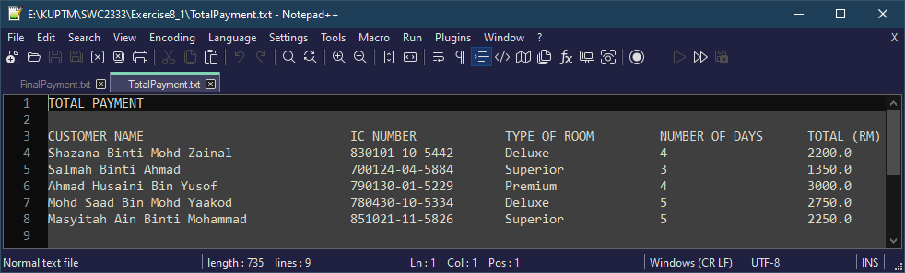

FinalPayment.txt

